

**EON Smart Connectors**

**Release Notes Feb’21**

**Version: 1.0**

.



# Contents

Contents 2

1. List of connectors 3

2. What’s New 3

* ACP Level Changes.…………………………………………………………………………………………………………………………….…3
  + ORACLE REVERSE…………………………………………………………………………………………………………………………3
  + ORACLE PROCEDURE EXPORT………………………………………………………………………………………………….4
  + INFORMATICA REVERSE ……………………………………………………………………………………………………4
  + POWERBI SMART CONNECTOR………………………………………………………………………………..……5

* Jar Level Changes……………………………………………………………………………………………………………………………....6
* ORACLE REVERSE ……………………………………………………………………………………………………………6
* ORACLE PROCEDURE EXPORT……………………………………………………………………………………….6
* Documentation Changes……………………………………………………………………………………………………………………..7
* ORACLE REVERSE ……………………………………………………………………………………………………………………7
* ORACLE PROCEDURE EXPORT ………………………………………………………........................................7
* INFORMATICA REVERSE………………………………………………………………………………………………….7
* POWERBI SMART CONNECTOR…………………………………………………………………………………….7

# List of connectors

.

* ORACLE REVERSE
* ORACLE PROCEDURE EXPORT
* INFORMATICA REVERSE
* POWERBI SMART CONNECTOR

# What’s New

* **ACP Level Changes**

**1) ORACLE REVERSE:**

* **Standardization of CAT name and CAT group and addition of connector description and logo.**

Previous:



Current:

s

* **Code Standardization.**

We have implemented code standardization at ACP level in latest cat.

**2) ORACLE PROCEDURE EXPORT:**

* **Standardization of CAT name and CAT group and addition of connector description and logo.**

Previous:



Current:



* **Code Standardization.**

We have implemented code standardization at ACP level in latest cat.

**3) INFORMATICA REVERSE**

* **Standardization of CAT name and CAT group and addition of connector description and logo.**

Previous:

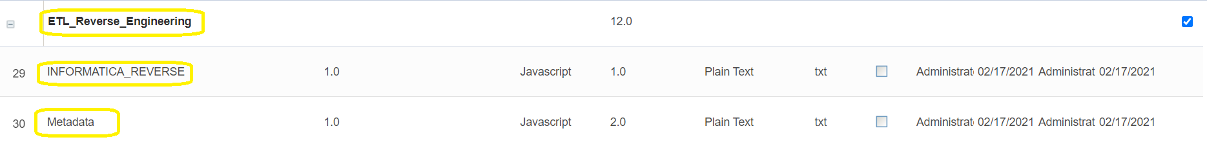

Current:





**4) POWERBI SMART CONNECTOR**

* **Standardization of CAT name and CAT group and addition of connector description and logo.**

Previous:



Current:



* **Addition of logo to the connector**

Previous:

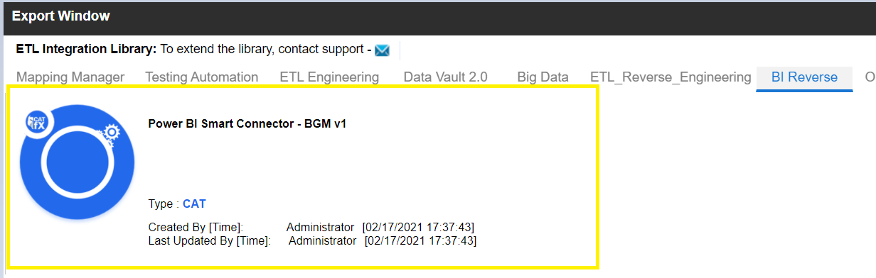

Current:

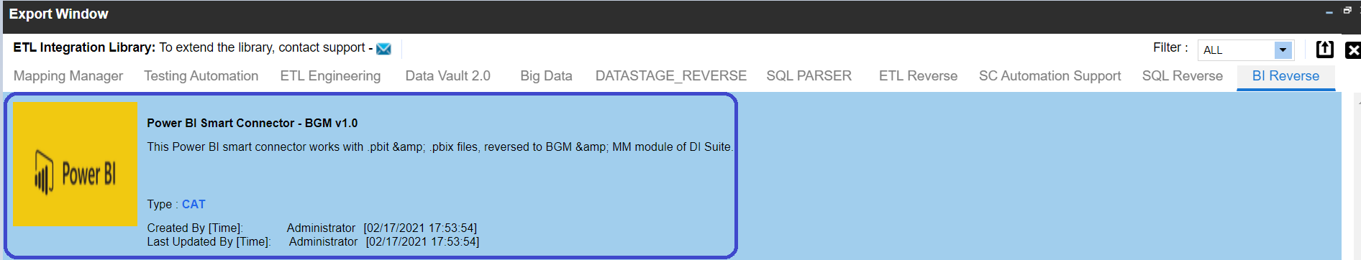

* **Jar Level Changes**

**1) ORACLE REVERSE**

* **Jar optimization**

Previous:



Current:



**Note:**

* Please remove **CFX_S_AF_SQLParser_v1.0** jar from EMM lib.
* Please remove **CFX_D_Z_Sync_Metadata_v1.0** jar from EMM lib.

**2)** **ORACLE PROCEDURE EXPORT**

* **Jar optimization**

Previous:



Current:



**Note:**

Please remove **Oracle Procedure** jar from EMM lib.

* **Documentation Changes**

**1) ORACLE REVERSE**

* **Updated User Guide and Installation guide with few Screenshot.**



**2) ORACLE PROCEDURE EXPORT**

* **Updated User Guide and Installation guide with few Screenshot.**



**3) INFORMATICA REVERSE**

* **Updated User Guide and Installation guide with few Screenshot.**



**4) POWERBI SMART CONNECTOR**

* **Updated User Guide and Installation guide with few Screenshot.**

